**PORTFOLIO**

ASSIGNMENT OF CSE111

(ORIENTATION TO COMPUTING-1)

**COMPUTER SCIENCE AND ENGINEERING**

Submitted by:

Name: MOHIT RAJ DEO

Registration number: 12323329

Roll No.:02

Section: K23ZR

**Submitted to :**

**Dr.Avinash kaur ma’am**



**LOVELY PROFESSIONAL UNIVERSITY**

**DECLARATION**

I, Mohit Raj Deo, a student of Bachelor of Technology under CSE discipline at Lovely Professional University, Punjab, hereby declare that all the information furnished in this project report is based on my own work and is genuine .

MOHIT RAJ DEO

Registrartion Number: 12323329

|  |  |  |
| --- | --- | --- |
| Platforms for profile creation | Link to student profile | Screenshot |
| ***Figma*** | Since internal profile doesn’t work, so I am attaching project link  Project1:  <https://www.figma.com/file/tv8iyfW0UFtDxLkHIJNPCD/Untitled?type=design&node-id=1-3&mode=design&t=epzpwnX1gEcf0M3T-0> | 5 |
| ***Quora*** | <https://www.quora.com/profile/Mohit-Raj-219> | 6 |
| ***Stack overflow*** | <https://stackoverflow.com/users/22934201/mohit-raj-deo> | 7 |
| ***Hacker Rank*** | <https://www.hackerrank.com/profile/mohitrajdeo16de1> | 8 |
| ***Hacker Earth*** | <https://www.hackerearth.com/@mohitrajdeo16deoghar> | 9 |
| ***Geeks for Geeks*** | <https://auth.geeksforgeeks.org/user/mohitrajdeoidn2/> | 10 |
| ***LinkedIn*** | <https://www.linkedin.com/in/mohit-raj-a4381a288/edit/forms/intro/new/?profileFormEntryPoint=PROFILE_SECTION> | 11 |
| ***Github*** | <https://github.com/MOHITRAJDEO12345> | 8 |
| ***Git*** |  | 9 |
| ***CV*** | <https://drive.google.com/file/d/1E4mB3gxMumYbgdIk1ZsP2aVBOEyzh7nV/view?usp=sharing> | 10 |
| ***MOOCS done*** | 1. <https://www.udemy.com/share/102Kyi3@7T0A-Rp5teaPIk2PasseGP0VyzKuPYopwd_n968Uk3zk3IN0fspwTkY4RTw0fzZCjQ==/>   .<https://www.udemy.com/share/109i1w3@SIQTEm0RlGY7gEOHlkZxp7rpwjqxncWSmKxqdRVsuHyBDhinfZ84pfwoymupOjuDzw==/>  3.  <https://www.udemy.com/course/learn-computer-basics-hardware-network-complete-tutorials/> | 11 |
| ***Technical MOOC Registration*** | Registration link  <https://www.open.edu/openlearn/digital-computing/introduction-cyber-security-stay-safe-online/content-section-overview?active-tab=description-tab> |  |

1.FIGMA

Profile:

Figma internal profile with project

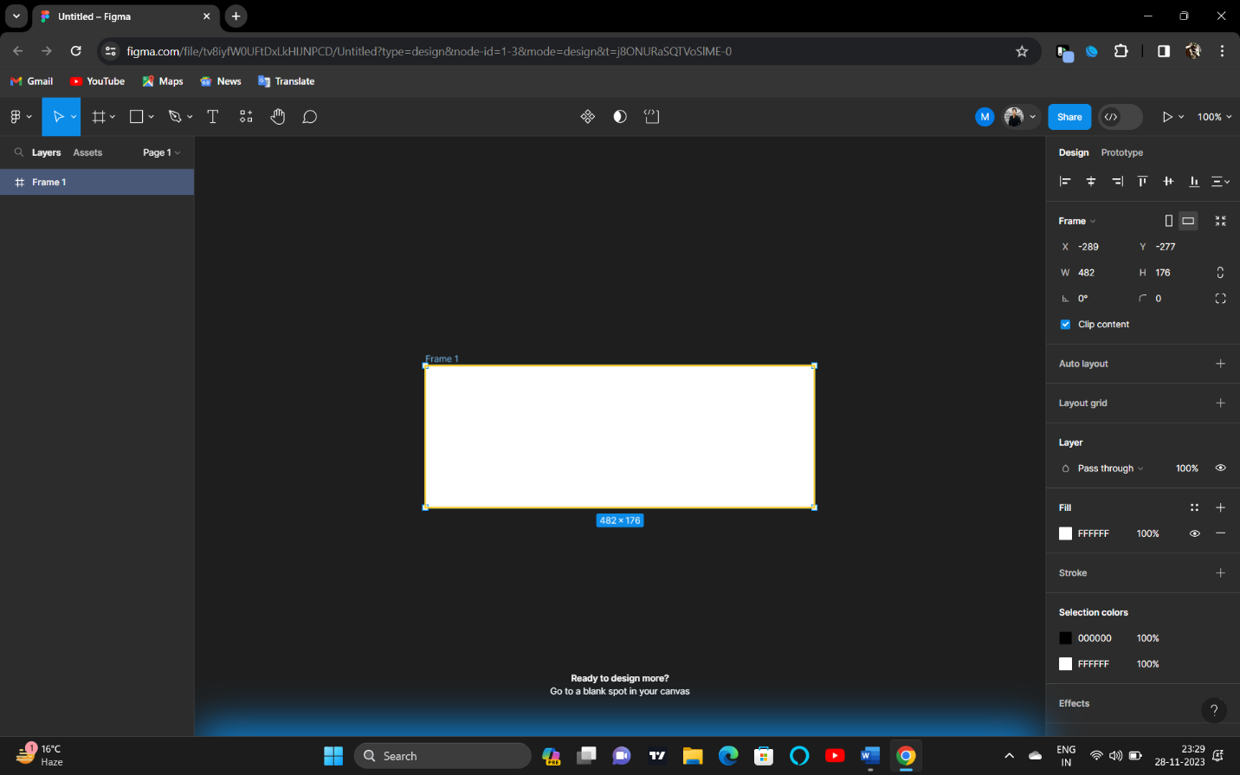

2.QUORA

PROFILE AND ACCOMPLISHMENT:

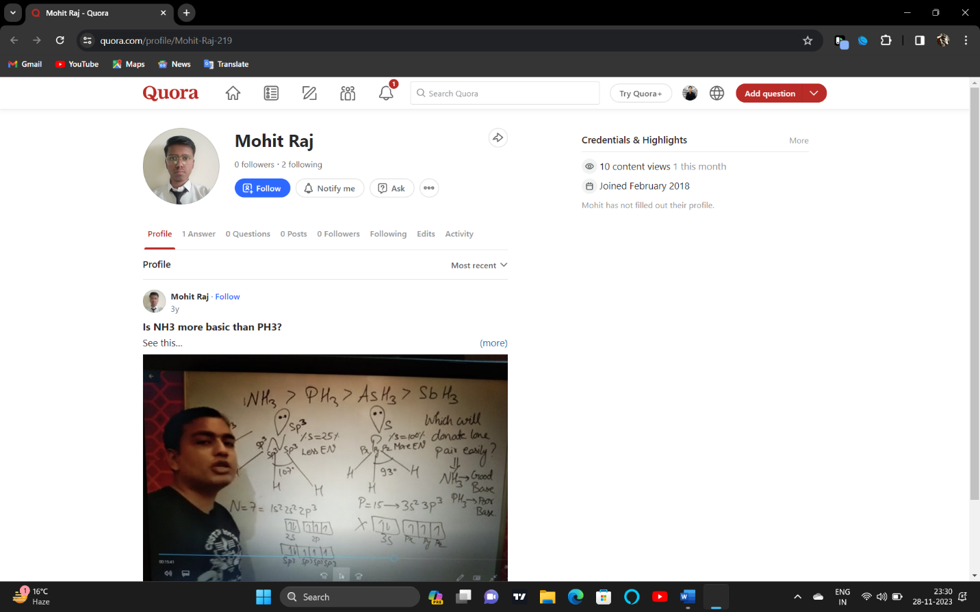

3.STACKOVERFLOW

PROFILE:

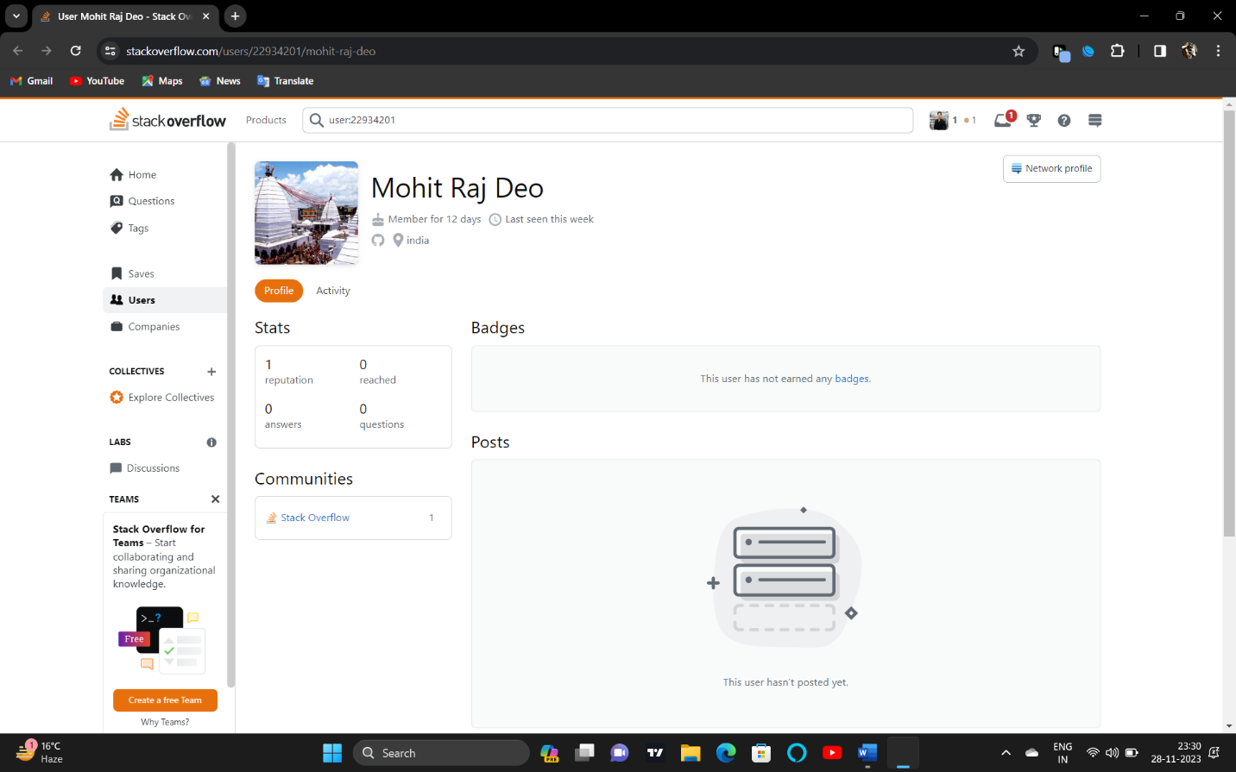

**4.HACKER RANK**

**Profile:**

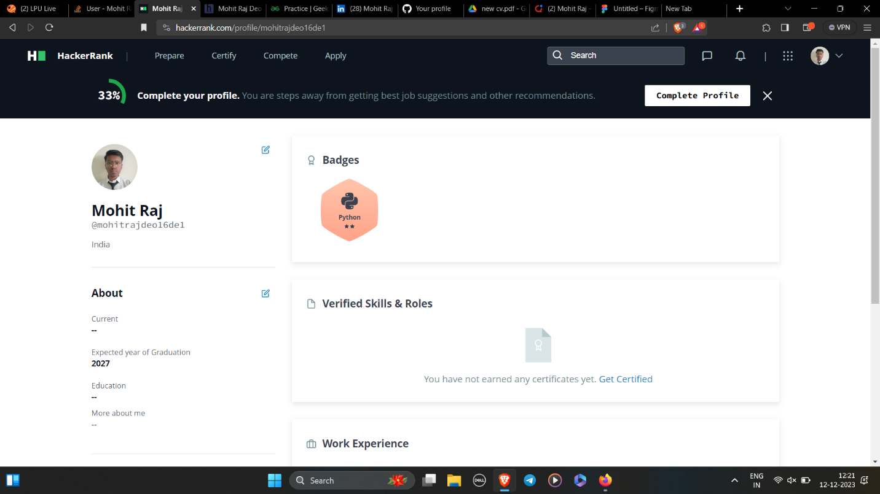

**5.HACKER EARTH**

**Profile:**

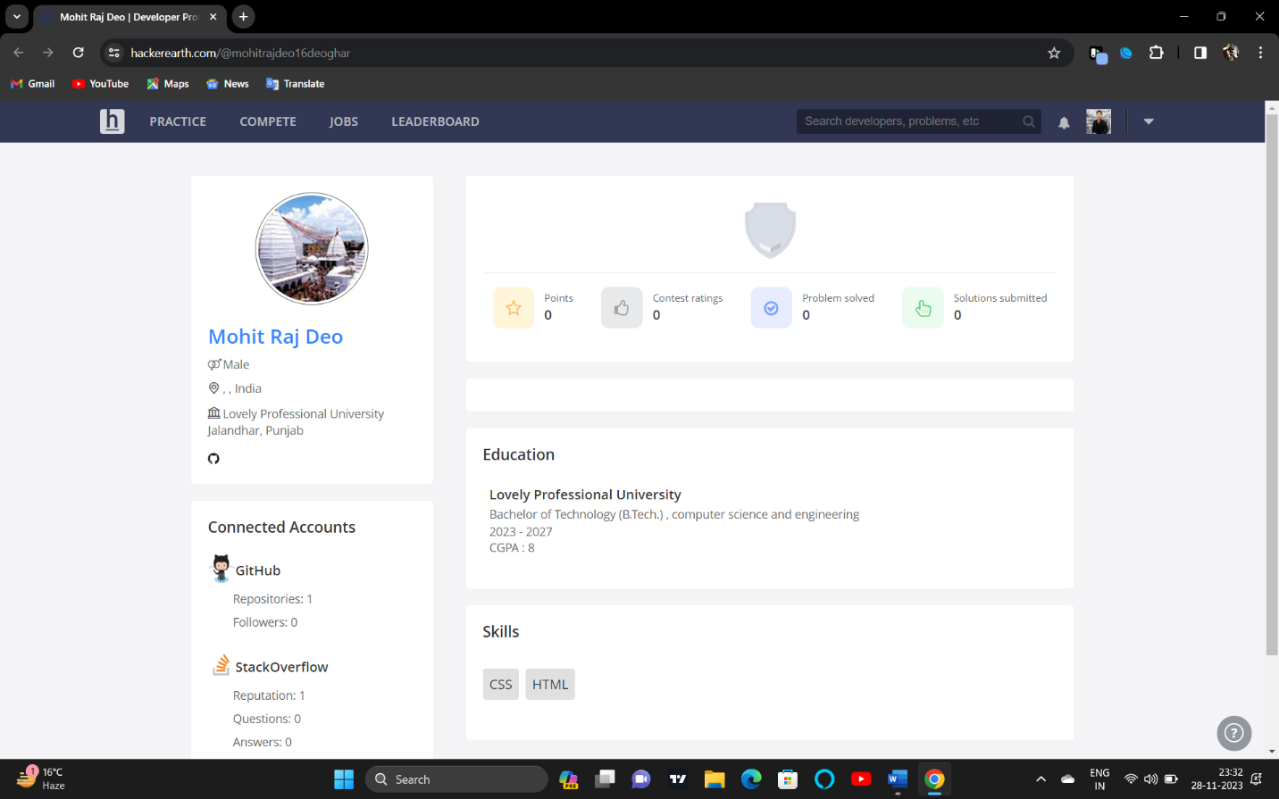

**7.GEEKS FOR GEEKS**

**Profile:**

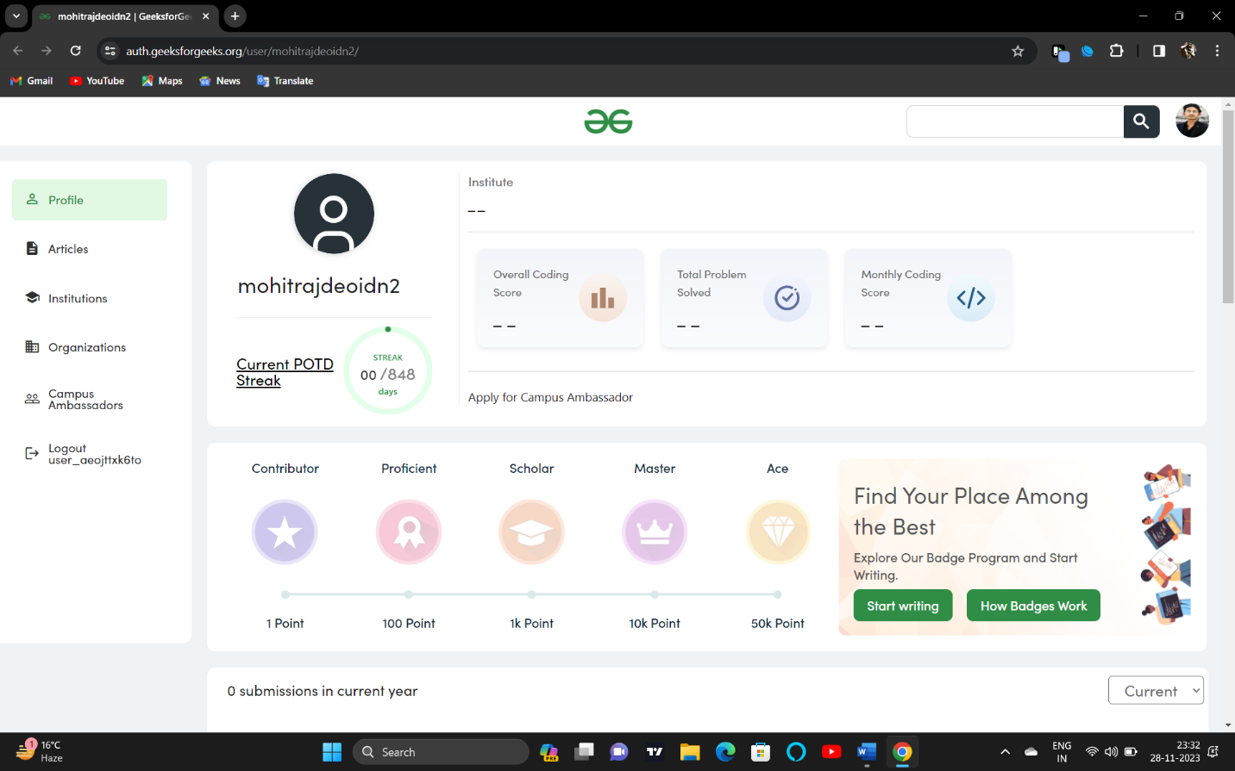

**8.GITHUB**

**Profile:**

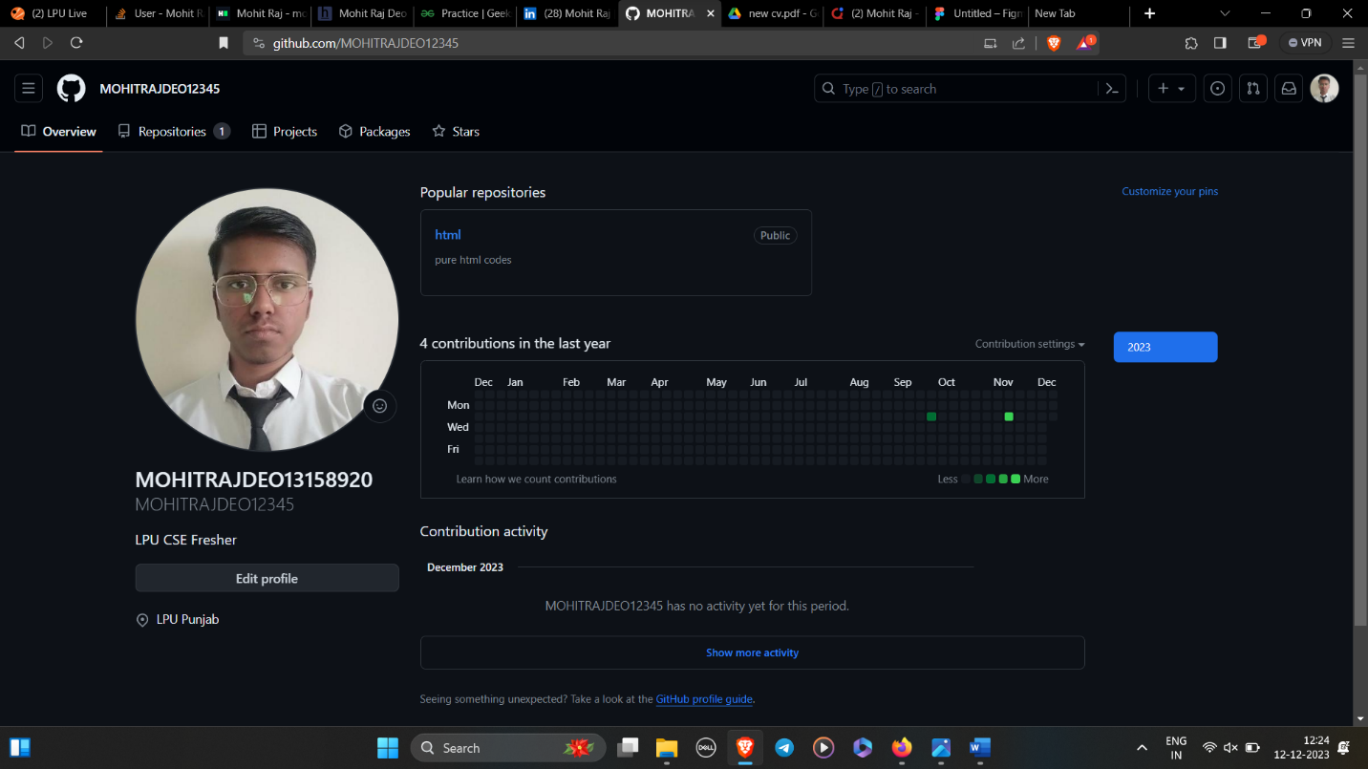

**9.LINKEDIN**

**Profile:**

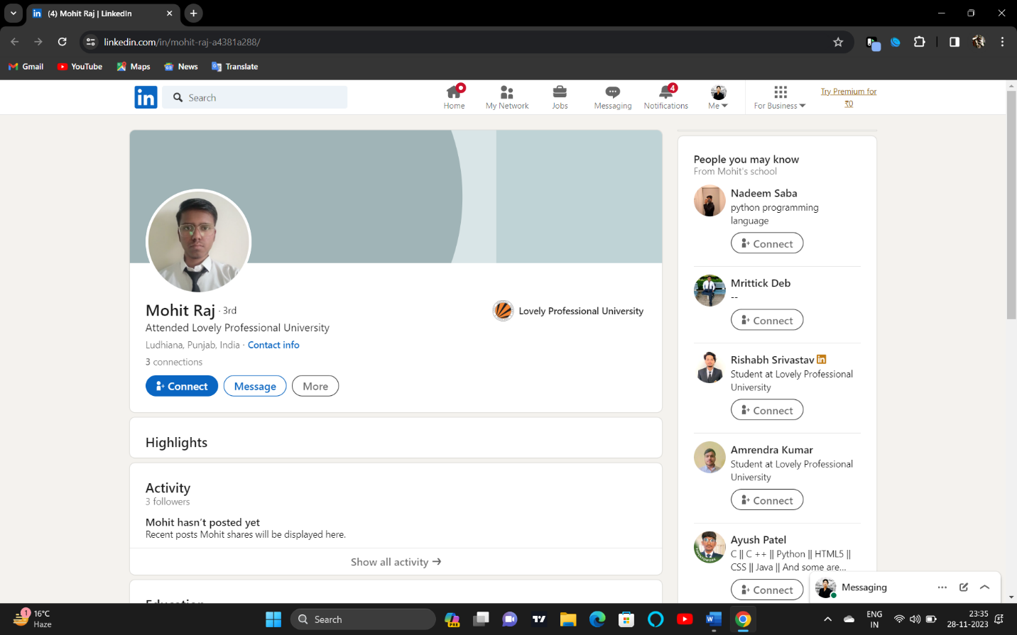

**10.CV**

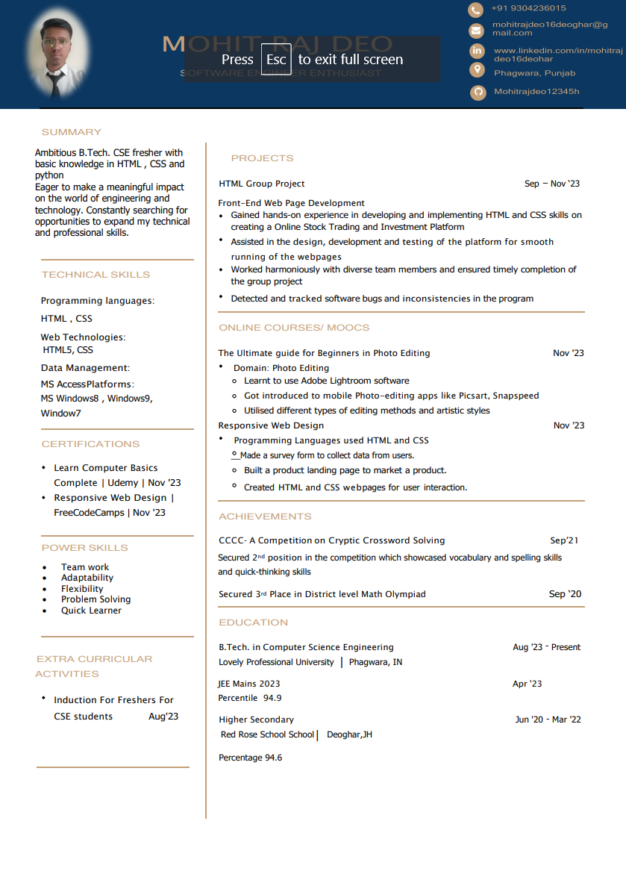

**11.MOOCS completed**



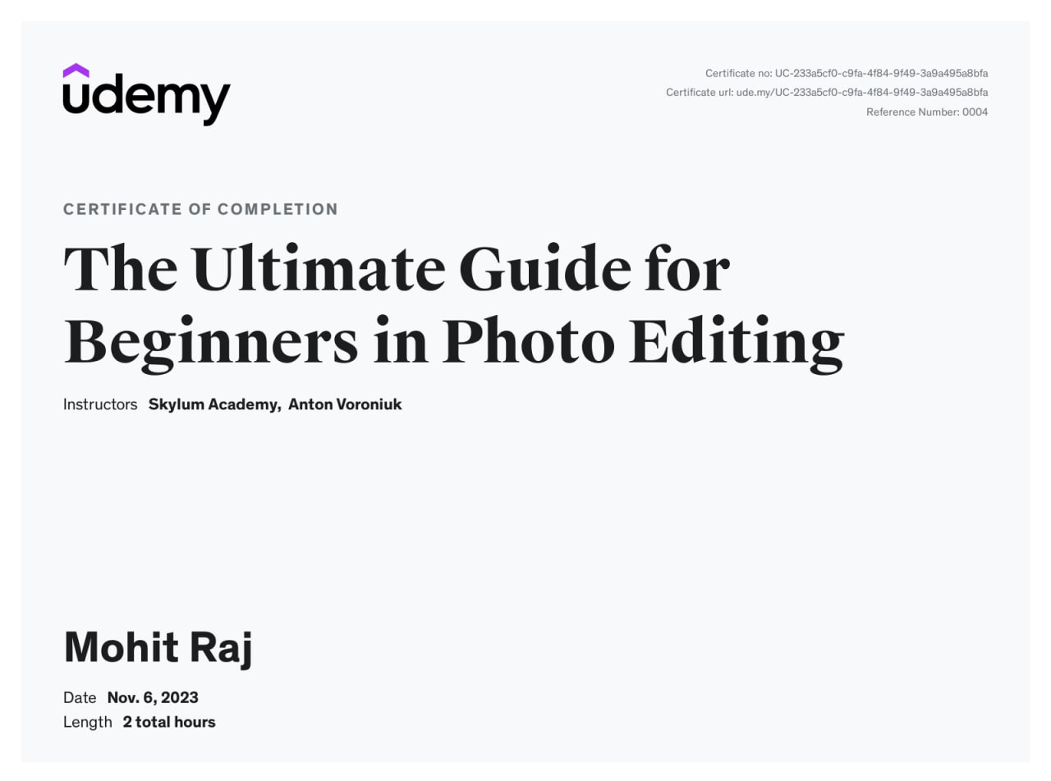

**11.Technical MOOCS**

